APUNTES MYSD SEMANA 4
(19.16-19-19)
Attributes
An attribute is a logical data value of an object.
Guideline: When to Show Attributes?
Include attributes that the requirements ( for example, use cases) suggest or
imply a need to remember information

For example, a receipt (which reports the information of a sale) in the Process
Sale use case normally includes a date and time, the store name and address,
and the cashier ID, among many other things.

Applying UML: Attribute Notation ATTRIBUTES Attributes are shown in the second compartment of the class box (see Figure 9.19). Their type and other information may optionally be shown.
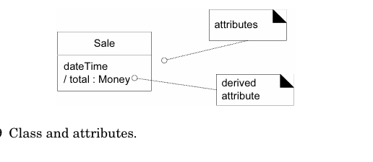
More Notation
The full syntax for an attribute in the UML is:
visibility name : type multiplicity = default {property-string}
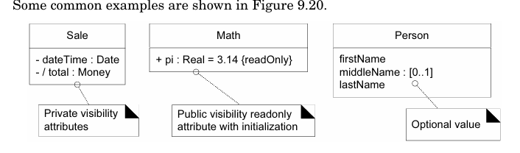

As a convention, most modelers will assume attributes have private visibility (-) unless shown otherwise, so I don’t usually draw an explicit visibility symbol.
{readOnly} is probably the most common property string for attributes.
Multiplicity can be used to indicate the optional presence of a value, or the num ber of objects that can fill a (collection) attribute. For example, many domains require that a first and last name be known for a person, but that a middle name is optional. The expression middleName : [0..1] indicates an optional value—0 or 1 values are present.
Derived Attributes
The total attribute in the Sale can be calculated or derived from the information in the SalesLineItems. When we want to communicate that 1) this is a noteworthy attribute, but 2) it is derivable, we use the UML convention: a / symbolbefore the attribute name.
Guideline: What are Suitable Attribute Types?
Focus on Data Type Attributes in the Domain Model
Informally, most attribute types should be what are often thought of as “primitive” data types, such as numbers and booleans. The type of an attribute should not normally be a complex domain concept, such as a Sale or Airport.
Guideline
The attributes in a domain model should preferably be data types. Very common data types include: Boolean, Date (or DateTime), Number, Character, String (Text), Time.
Other common types include: Address, Color, Geometrics (Point, Rectangle), Phone Number, Social Security Number, Universal Product Code (UPC), SKU, ZIP or postal codes, enumerated types
Guideline Related conceptual classes with an association, not with an attribute

Data Types
As said, attributes in the domain model should generally be data types; infor
mally these are “primitive” types such as number, boolean, character, string, and
enumerations (such as Size = {small, large}).

Perspectives: What About Attributes in Code?
The recommendation that attributes in the domain model be mainly data types
does not imply that C# or Java attributes must only be of simple, primitive data
types. The domain model is a conceptual perspective, not a software one. In the
Design Model, attributes may be of any type.

Guideline
Represent what may initially be considered a number or string as a new data
type class in the domain model if:
■ It is composed of separate sections.
❍ phone number, name of person
■ There are operations associated with it, such as parsing or validation.
❍ social security number
■ It has other attributes.
❍ promotional price could have a start (effective) date and end
date
■ It is a quantity with a unit.
❍ payment amount has a unit of currency
■ It is an abstraction of one or more types with some of these qualities.
❍ item identifier in the sales domain is a generalization of types
such as Universal Product Code (UPC) and European Article
Number (EAN)

Guideline: Modeling Quantities and Units
Most numeric quantities should not be represented as plain numbers. Consider
price or weight. Saying “the price was 13” or “the weight was 37” doesn’t say
much. Euros? Kilograms?

These are quantities with associated units, and it is common to require knowl
edge of the unit to support conversions.

9.18
Conclusión: ¿Es correcto el modelo de dominio?
No existe un único modelo de dominio correcto. Todos los modelos son aproximaciones del dominio que intentamos comprender; el modelo de dominio es principalmente una herramienta de comprensión y comunicación entre un grupo específico.
Un modelo de dominio útil captura las abstracciones y la información esenciales necesarias para comprender el dominio en el contexto de los requisitos actuales y ayuda a comprenderlo: sus conceptos, terminología y relaciones.

9.19 Process: Iterative and Evolutionary Domain Modeling

Guideline
Avoid a waterfall-mindset big-modeling effort to make a thorough or “cor
rect” domain model—it won’t ever be either, and such over-modeling efforts
lead to analysis paralysis, with little or no return on the investment.
Limit domain modeling to no more than a few hours per iteration

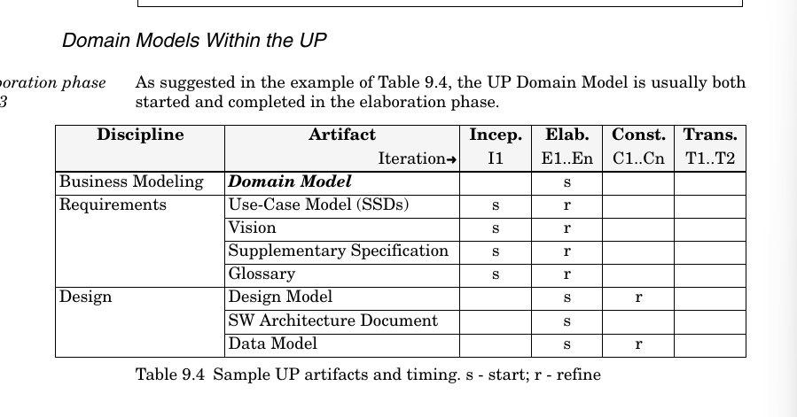
Inception
Domain models are not strongly motivated in inception, since inception’s purpose is not to do a serious investigation, but rather to decide if the project is worth deeper investigation in an elaboration phase.

Elaboration
The Domain Model is primarily created during elaboration iterations, when the need is highest to understand the noteworthy concepts and map some to software classes during design work.

The UP Business Object Model vs. Domain Mode

The UP Domain Model is an official variation of the less common UP Business
Object Model (BOM). The UP BOM—not to be confused with the many other
definitions of a BOM—is a kind of enterprise model that describes the entire
business

[The UP BOM] serves as an abstraction of how business workers
and business entities need to be related and how they need to
collaborate in order to perform the business. [RUP]

The BOM is represented with several different diagrams (class, activity, and
sequence) that illustrate how the entire enterprise runs (or should run). It is
most useful if doing enterprise-wide business process engineering, but that is a
less common activity than creating a single software application.

32.2-32.5 y el resto del libro tercera edición no sale eso
CAPITULO 28 DE LA PRIMERA EDICION
Generalizacion
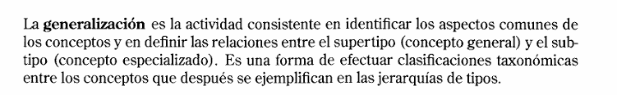
Supertipo: concepto más general
Subtipo: concepto más especializado
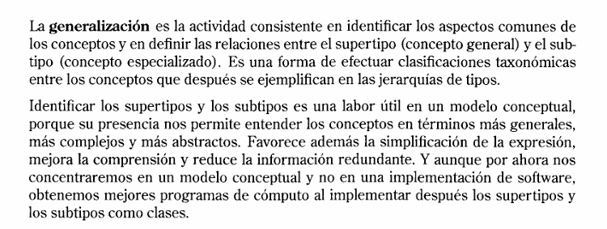

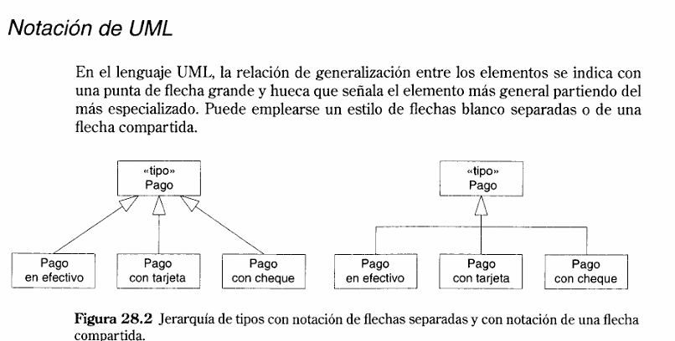

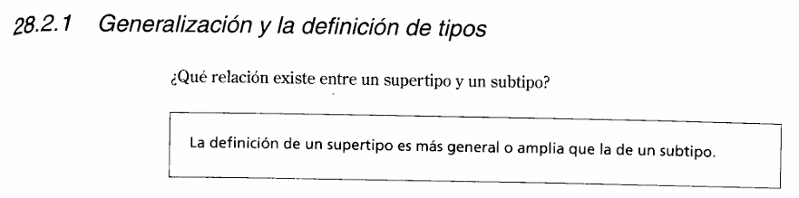
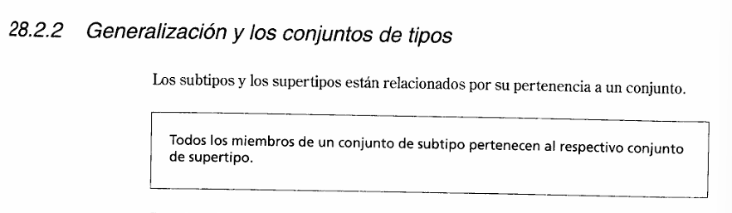
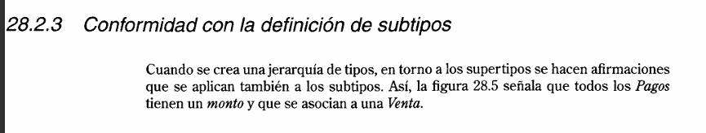
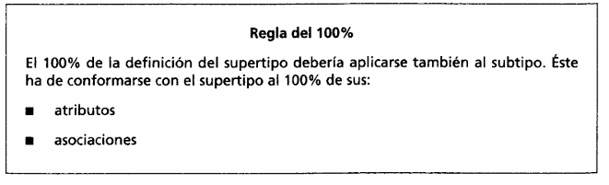
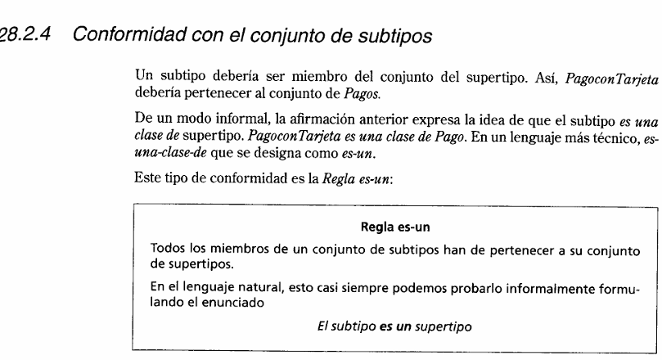
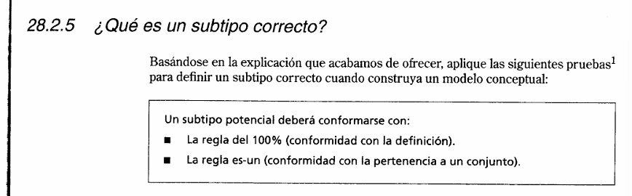
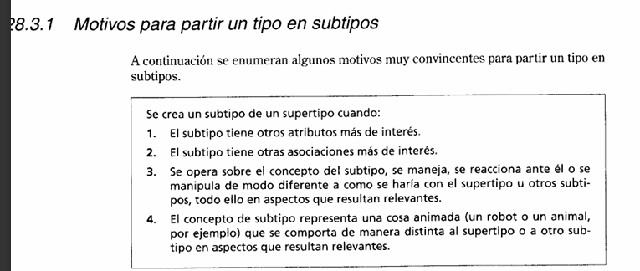

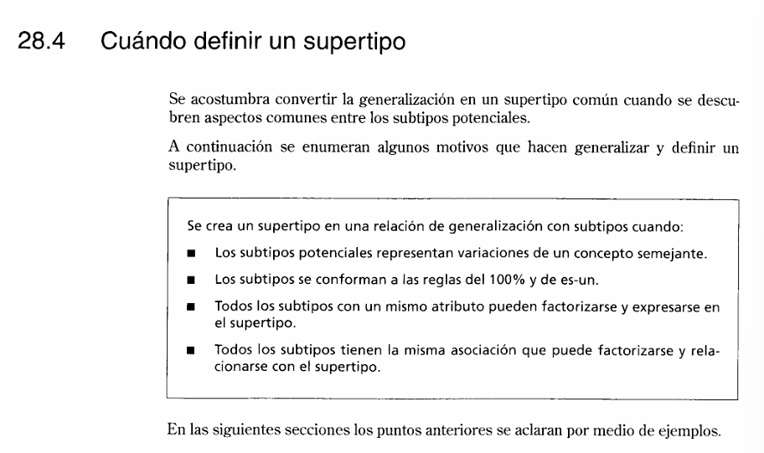

Jerarquia de los tipos del punto de ventas
- Tipos de pago
- Tipos del servicio de autorización

